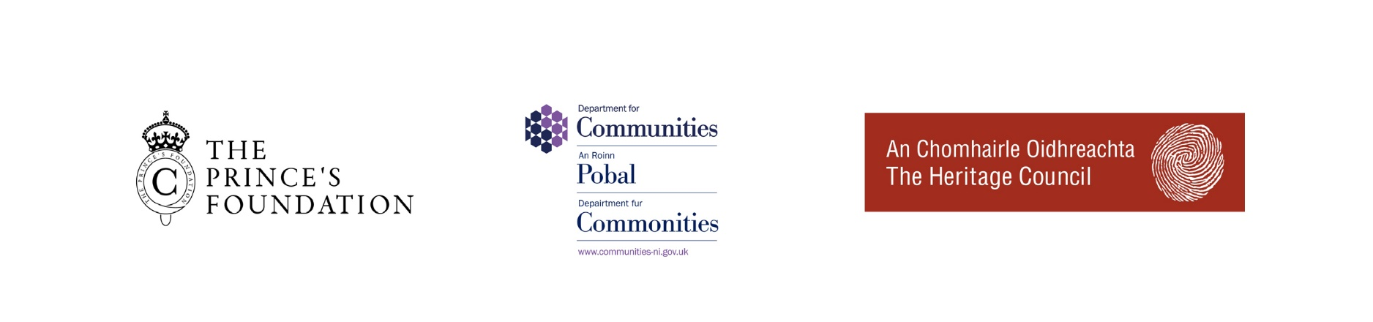

All-Ireland Heritage Skills Programme 2022

DEADLINE FOR RECEIPT OF APPLICATIONS IS MONDAY 23RD MAY 2022, 12 NOON

Thank you for expressing an interest in the All-Ireland Heritage Skills Programme 2022. Please read and complete this application form and return it to us with the accompanying documents by Monday 23rd May 2022, 12 noon.

Prior to submitting your application, please ensure that you have downloaded and read the course overview which outlines the course structure, key dates:
https://princes-foundation.org/education/all-ireland-programme

Geared at those with experience in building craft areas such as: stonemasonry, carpentry and joinery, bricklaying, blacksmithing, plastering, thatching, roofing and tiling, painting and decorating, the All-Ireland Heritage Skills Programme aims to support the next generation of craftspeople push their skills to the next level. The programme has been designed to offer successful applicants a structured twelve-month programme of tuition and practical experience and provide the opportunity to work towards a Level 3 NVQ in Heritage Skills (Construction).

We are looking for applicants with the will to succeed in the rapidly expanding heritage building and conservation sector, and the desire to use and develop their skills to improve the built environment for this, and future generations.

The All-Ireland Heritage Skills Programme is not an entry level programme and to be successful in gaining a place on the course, candidates must have prior experience in their craft area of choice, either via college or onsite working experience.

To be considered for one of the places, applicants must be able to demonstrate at least one of the following:

- NVQ Level 2 or 3 / Level 4 or 5 Certificate in a building craft/construction subject
and/or
- An equivalent qualification in traditional building skills from a recognised authority
and/or
- An equivalent amount of working experience in your chosen craft/trade area.

If you are unsure if you have the required level of experience, please contact the Programme Coordinator.

PLEASE COMPLETE ALL SEVEN SECTIONS OF THIS APPLICATION FORM

PERSONAL DETAILS

  - Full name:
  - Permanent address:

  - Postcode / Eircode:
  - Telephone (landline):
  - Telephone (mobile):
  - Email:
  - Date of birth:

  - What is your craft / trade area?*
*i.e. stonemason, bricklayer, joiner and blacksmith

  - Please confirm your current residency status:

☐ UK Passport Holder
☐ Republic of Ireland Passport Holder
☐ Settled Status / Indefinite Leave to Remain in the UK
☐ Pre-settled Status in the UK
☐ Other, please specify:

TRAINING AND QUALIFICATION

- Which college, if any, are you presently attending?

- What is the full title of the course you are studying?

- When did you start the course and when do you finish?

Please list qualifications that you have obtained, starting with your most recent qualification*:

Dates attended | Course title / qualification level | Grade achieved | College/training provider

*Continue on separate page if needed

CAREER HISTORY

- Are you currently in work? ☐ Yes ☐ No
- Name and address of your employer or contractor:

- What job do you do? Please list your main tasks/responsibilities.

- How long have you been in this employment?

- Give details of relevant previous work, including dates and a description of what you did*:

Dates of employment | Name and address of employer | What role did you do?  Please outline main tasks and responsibilities

* Continue on separate page if needed

REASON FOR APPLICATION

- In no more than 500 words, please tell us why you are applying for the programme and what you hope to achieve from it should you be offered a place?

- In no more than 250 words, what would you like to achieve in the next five to ten years?

- In no more than 250 words, why do you think it is important to preserve heritage skills?

REFERENCE

Please provide a full and complete reference, including the contact details of your referee who must be either a tutor, employer or someone you have worked with in a professional capacity. The referee must be able to vouch for your skills and experience, and provide details including to the following questions.

- How long have you known the applicant, and in what context?
- How do you feel the applicant would benefit from the programme, and what skills and abilities do they have that the scheme will build on?

Name of Referee:

Address of Referee:

Email Address:

In what capacity do
you know this person? :

Please ask your referee to send their reference directly to the Programme Coordinator, Ben Mc Cabe ben.mccabe@princes-foundation.org.

Due to the number of applications we receive we cannot approach each referee directly. Please ensure that we receive your reference before the application deadline.

- PORTFOLIO

To support your application, you are required to submit a digital portfolio containing relevant images of work and projects you have been involved in. You may also include other images/examples of work that you feel demonstrates your broader interest in the built environment, e.g. drawings, experience of other craft disciplines etc.

Please ensure that your portfolio adheres to the following guidelines:

· Portfolio contained in ONE PDF file. (Please do not send multiple single file images)
· Your PDF file is no greater than 20mb
· Images are annotated to show nature of the work, your role, year completed.

Please tick the box below to confirm that you have read the PDF portfolio guidelines.

☐ I have read the above guidelines on submitting a digital portfolio.

- DECLARATION

BY SIGNING BELOW, YOU ARE AGREEING TO THE FOLLOWING:

I hereby certify that all information provided in this application and any attachments is true and complete. I understand that any false information or omission may disqualify me from further consideration, or, if I am successful in gaining a place, may result in my dismissal from the programme if discovered at a later date.

APPLICANT’S SIGNATURE: DATE:

APPLICATION CHECKLIST

To complete your application, please ensure that we receive the following:

- Completed and signed application form.
- A reference from your chosen referee.
- Copies of relevant academic or professional certificates (do not send originals)
- A digital portfolio of your work.

DEADLINE FOR RECEIPT OF APPLICATIONS IS

MONDAY 23RD MAY 2022, 12 NOON

PLEASE SEND YOUR APPLICATION AND ACCOMPANYING DOCUMENTS TO:

Ben Mc Cabe
Programme Coordinator
ben.mccabe@princes-foundation.org

